**Solar Car 1 MPPT Design**

**Helpful links:**

* Solar cell equivalent circuit: <https://www.allaboutcircuits.com/technical-articles/circuit-designer-guide-to-photovoltaic-cells-solar-powered-devices/>
* Boost converter MPPT simulation: <https://www.youtube.com/watch?v=o9BOrAHH5E4>
* Discussion on MPPT vs charge controlling: <https://electronics.stackexchange.com/questions/519900/understanding-working-of-mppt-charger>
* Complete open source buck MPPT design: <https://www.instructables.com/DIY-1kW-MPPT-Solar-Charge-Controller/>

**Questions:**

Buck or boost converter?

* Contingent on motor voltage: if > 100V or so, want boost, if less consider boost
  + The reason for this is we want to be able to use integrated buck converter IC’s on the board for peripheral voltages (i.e. 12V, 3.3V) and these packages rarely are rated for VIN > 80V or so.

How does altering duty cycle of these converters move you along the solar IV curve?

- Buck?

- Boost?

Can MPPT buck/boost converter be the same as the charge controller or do we need two with a DC link?

* In order to ideally use one controller as both, two things must be true:
  1. Can accurately do pure current control (NOT MPPT) when battery is charging
     + Must be able to distinguish Iload from Icharge
     + Develop charge algorithm to take over MPPT when Iload < Iarray
       - Two scenarios:
         * Iarray – Iload < ideal charge current for current SOC

Continue MPPT

* + - * + Iarray – Iload > ideal charge current for current SOC

Current control necessary

* + - * To get charging current to decrease, the converter will have to increase the impedance of the converter by altering duty cycle (*­­­­­_______* on buck converter, *______* on boost converter) to utilize the decaying nature of current as voltage increases on the IV curve)
        + Must size pack to have max voltage to the voltage to where the minimum desired charging current lies on IV curve (or just max solar array voltage, as voltage is pretty constant at end of the IV curve).
  1. **Hardware** failsafe shutoff of converter if battery voltage is above certain threshold

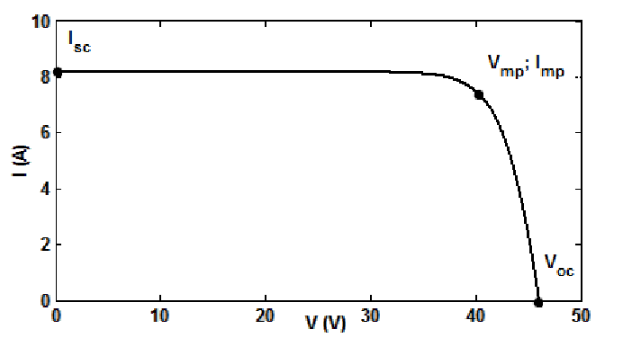

*Pictured: Increasing output voltage will decrease input current in a charging scenario*.

What happens if the maximum power point impedance/duty cycle yields a higher output voltage than the battery voltage?

**Characterize following scenarios:**

Buck converter:

* MPP duty cycle output is > in voltage than battery
  1. Iload > Ipanels
  2. Iload < Ipanels (charging)